Постоянное Представительство  Российской Федерации  при  Организации Объединенных  Наций  Phone: (212) 861-4900 | 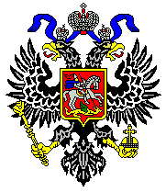 | Permanent Mission  of the Russian Federation  to the United Nations  136 East 67th Street  New York, NY 10065  Fax: (212) 628-0252  517-7427

STATEMENT

20 October 2008

ON FUNDRAISING LETTER FROM
JOHN MCCAIN ELECTION CAMPAIGN

We have received a letter from Senator John McCain requesting financial contribution to his Presidential campaign.

In this connection we would like to reiterate that Russian officials, the Permanent Mission of the Russian Federation to the United Nations or the Russian Government do not finance political activity in foreign countries.

